**Project CS103 S2022**

**Coffee Machine**

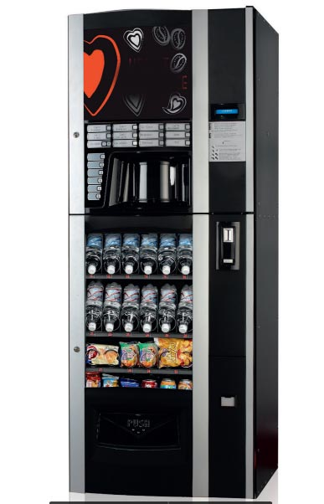

FERLIN Jules

Table of Contents

Subject 4

Answer 4

Structures 4

Modularity 4

Save 5

Drinks file 5

Money file 5

Files in details 6

Processing 6

Drinks 7

Money 7

Administration 7

Main.h 8

Result and upgrade 8

Conclusion 8

Upgrade 8

Project link 8

# Subject

The subject is very simple. We have to simulate an entire coffee machine. The coffee machine could provide about 5 types of coffee with a limited amount and it will ask for money, add this money to stock, give change et reduce money in stock.

For example:

“If we ask for espresso, and it costs 1 KM, we give 2 KM, if you don’t have coins to give back, (either 2X 0.5, or 1) you should send back the money, and say we don’t have change.

If we make 50 espressos, and want to make the 51st. The machine should say, sorry we don’t have this coffee any more, we have other types, would like to try (or something similar)

If we put 1 KM, the number coins in the machine will increase for 1 KM, if we put 5 KM, and machine give back 4X1 of 1 KM, then, the total of 1 KM coins should be reduced.”

# Answer

## Structures

I made 4 structures in order to have the simplest program. First one is for drinks, it gathers name, price and the number of drinks can be made. Second structures is for coins, it regroups the value of the coin and how many coins which remains. Third one is to store choice of user. It gathers a drink, money given, the number of the drink chosen and a structure to store coins given.

## Graphical user interface, application Description automatically generated with medium confidenceModularity

To divide the project in multiple part, I split in 4 different parts.

First part of the program is the processing’s files. These files compute all variables needed during the whole program and save data in file. They also contain function who compute some result needed during the program.

Second and third parts is for the management of drinks and money.

Last part is for administration mode where there are functions to add or remove drink from the list.

## Save

There are two files in order to save data at the end of the program.

### Drinks file

In the file for drinks, I store the number of types of coffee and details about them.

### Money file

In the file for money, I store only the value of coins and the amount for each of them.

## Files in details

For each part there are two files, a source file for the definition of each function and an header for the prototype of each function.

### Graphical user interface, text, application Description automatically generatedProcessing

In processing file there are 5 functions :

* Initialisation
* Print_info
* Saving
* Reset
* Parse_float

#### Initialisation:

This function sets all variables needed during the program like drinks and coins. It will read files and save data into structure drinks and coins. Both are pointers, because I need to modify it in the file. Moreover, when the function is called, I don’t know the size of drinks so I make a malloc to set the size. This function returns NULL if a problem appears or the pointer of the list of drinks

#### Table Description automatically generatedPrint_info:

Just print some information at start of the program

#### Saving:

This function saves information about drinks and coins into files. It check also if the name of drinks contains a space and replace it with an underscore (_).

#### Reset:

This functions replace the quantity of each drinks and each coins by 50

#### Parse_float:

This function is pretty similar to strtof but work better then strtof in my case because it will return -1 if the function founds a letter or other characters different than a number.

### Drinks

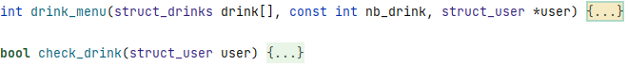In the drink file, I made 2 functions: drink_menu and check_drink

#### Text Description automatically generatedDrink_menu:

This function print a menu with all possible drinks and 3 more options: administration mode (code is 1234), reset and exit. It will return 0 if nothing wrong happen and the user wants a drink, 1 if the user chooses to enter in administration mode, 2 if the user wants to reset the machine, 3 if he wants to leave and 36 (crazy number) if a problem is found during the execution. The last one should never be returned.

#### Check_drink:

This function check if the number of the drink chosen is higher than 0. It return true if all correct and false if the number equals to 0.

### A picture containing diagram Description automatically generatedMoney

In the file for coins there are also 2 functions: coin_add and check_change.

#### Coin_add:

This function asks the user to enter the right amount of money for the drink chosen. It will stores each coins given and the total. It will return 0 if the user wants to cancel, 1 if user gave the right amount of money and 2 if the user gave more money than needed.

#### Check_change:

This function checks if the program have enough change to give back to user. If enough change is available it will return true and modify quantities of coins : add those given by the user and remove those gives back to the user. If there is no enough change it will return false.

### Graphical user interface, text, application Description automatically generatedAdministration

That was not ask by the professor but in a real coffee machine you can add or remove a drink from the list, so I wanted to code this part as well as other. In this file I implement 6 functions:

* Code_check
* Administration_menu
* Enter_code
* Add_drink
* Remove_drink
* Administration

#### Code_check:

This function checks if a equal to b. If a equals to b it will return true, if not it will return false.

#### Administration_menu:

This function prints a menu for administration mode and return the choice of the user.

#### Enter_code:

This function asks to enter the code needed to enter in the administration mode and checks if it is right or wrong by calling the function code_check. It will return true if the code is correct and false if not.

#### Add_drink:

This function asks the administrator to enter a new beverage and verify what he enters. Then it will use realloc to extend the size of the variable “drinks”. It will return the structure of drinks with the new drink.

#### Remove_drink:

This function asks the administrator which drink he wants to remove and removes it from the list. It will return the structure of drinks without the drink removed.

#### Administration:

This function is the main part of the administration mode. It calls others functions related to administration and executes all of them. It will return the list of drinks modified.

### Main.h

This file is an header file that helps. I only include one time all files in this header file and I have to include this file in each .c files. Otherwise it contains all definitions of structure.

# Result and upgrade

## Conclusion

At the end, this is a great project to do in team, even if I did it alone, and when we are beginner in programming. My program contain about 745 lines of code.

## Upgrade

The main upgrade can be to add more printf with text and details. We could add a function to modify the secret code to enter in administration mode

# Project link

<https://replit.com/join/rpwdsdmxcw-seluj78>

<https://github.com/Seluj/CS103-Project>